WAZUH SIEM
HOME LAB
Ubuntu deployment and Windows endpoint onboarding

Technical Implementation Guide
Prepared by Kagiso Lebambo

1. Project Overview
This document records a practical Wazuh SIEM home lab. The lab uses an Ubuntu virtual machine to host the Wazuh platform and a Windows device as a monitored endpoint. The documented work covers installation, dashboard access, agent registration, connectivity verification and review of endpoint events.

2. Lab Components
Component | Purpose in this lab
Ubuntu virtual machine | Hosts the Wazuh installation and manager services
Wazuh dashboard | Provides the web interface for monitoring and reviewing events
Windows endpoint | Runs the Wazuh agent and sends endpoint data to the manager

3. Wazuh Installation and Dashboard Access
Wazuh was installed on the Ubuntu virtual machine using the Wazuh installation assistant. After the installation completed, the web dashboard was opened in a browser and a successful login was confirmed.
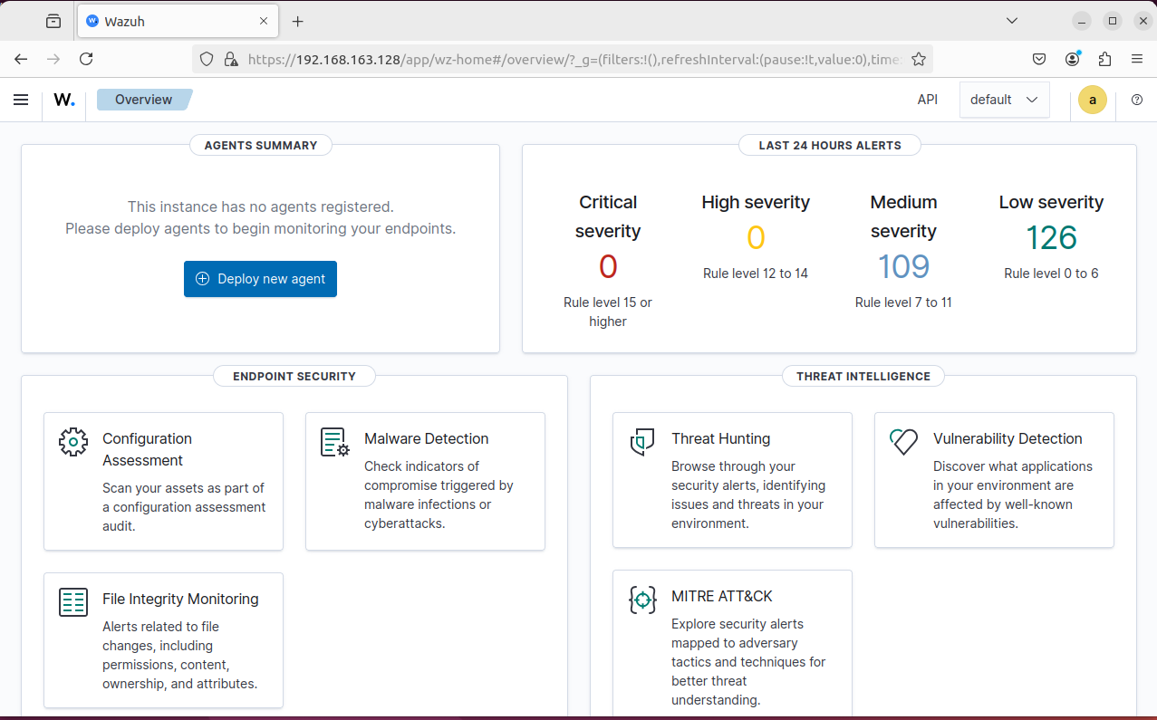
Figure 1. Wazuh dashboard after successful login.

4. Windows Agent Installation
The Wazuh agent was installed on the Windows endpoint. The agent setup interface was used to configure the connection to the Ubuntu-based Wazuh manager.
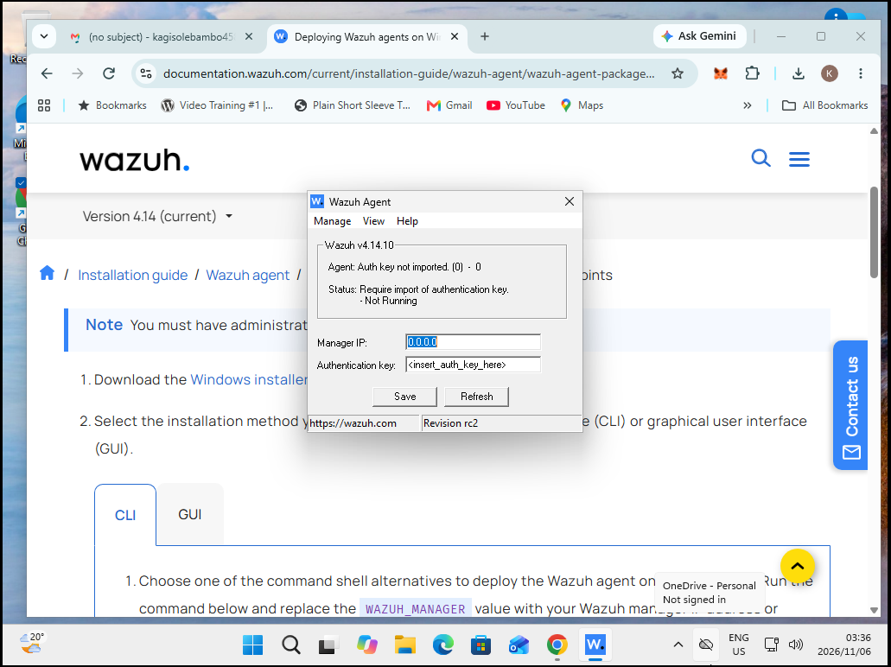
Figure 2. Windows endpoint agent setup.

5. Identify the Ubuntu Manager Address
The Ubuntu network interface configuration was checked to identify the manager address used by the Windows agent. The original screenshot is retained as evidence; review network details before sharing this guide publicly.
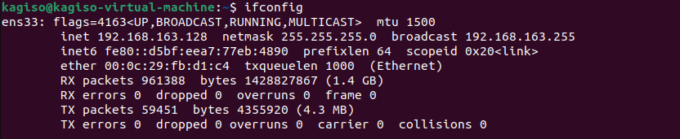
Figure 3. Ubuntu network interface information.

6. Register the Windows Agent on the Manager
The Wazuh agent management utility on Ubuntu was used to add the Windows endpoint. The endpoint was assigned an agent name and its manager connection details were prepared for enrolment.
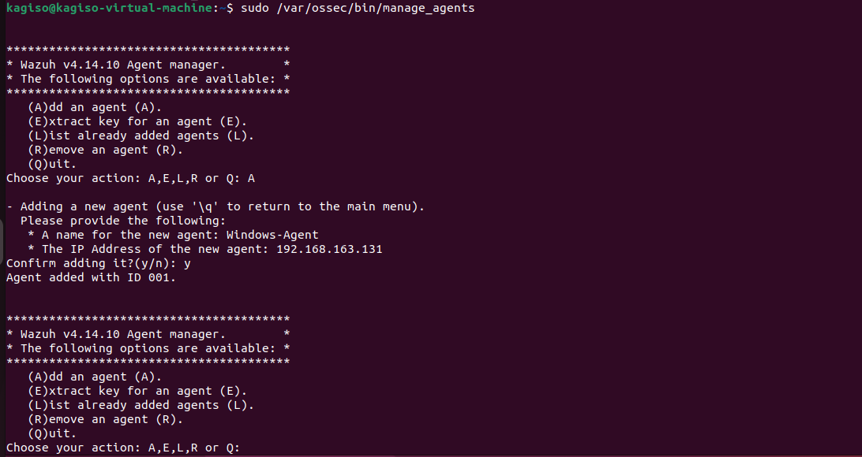
Figure 4. Adding the Windows endpoint using the Wazuh agent manager utility.

7. Retrieve and Configure Agent Authentication
The agent management utility was used to retrieve the registration key for the Windows endpoint. The key was then entered in the Windows Wazuh agent interface along with the Ubuntu manager address. Authentication material has been redacted from the screenshots in this public-sharing copy.
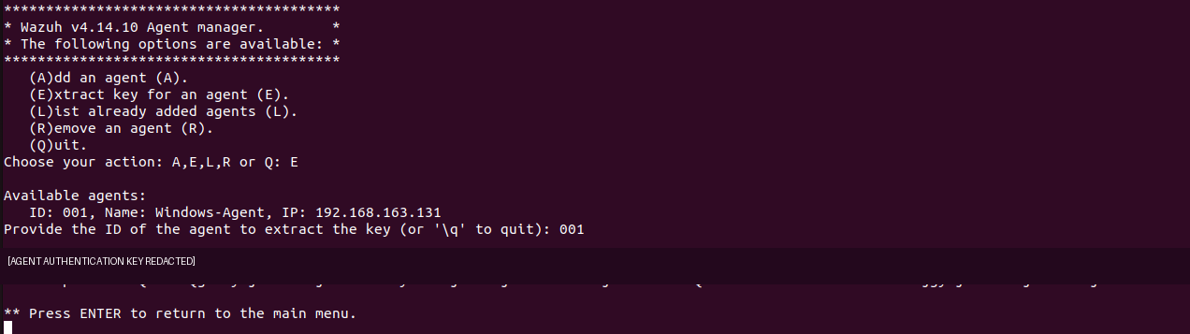
Figure 5. Agent key retrieval; authentication key redacted.
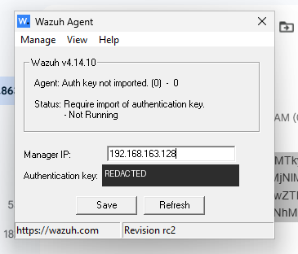
Figure 6. Windows agent connection settings; authentication key redacted.

8. Verify Successful Agent Onboarding
The Windows agent interface showed the agent running. The Wazuh dashboard also displayed the Windows endpoint as an active agent, confirming successful onboarding.
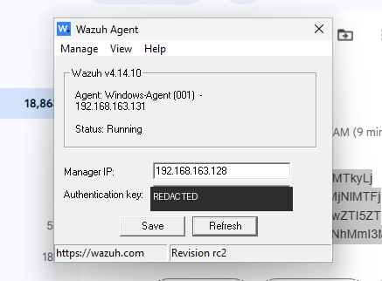
Figure 7. Windows agent running; authentication key redacted.
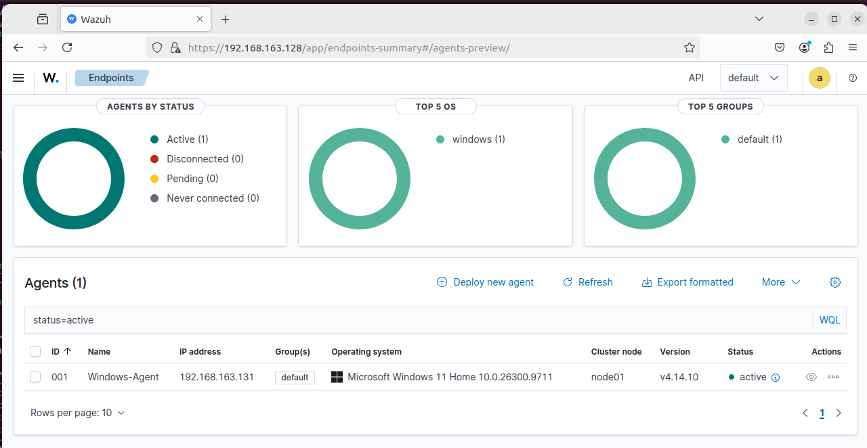
Figure 8. Windows endpoint visible in the Wazuh dashboard.

9. Review Endpoint Events and File Integrity Monitoring
The endpoint Events view was opened in the Wazuh dashboard. The captured view shows events associated with the Windows agent and file activity, demonstrating that endpoint telemetry was reaching the Wazuh platform.
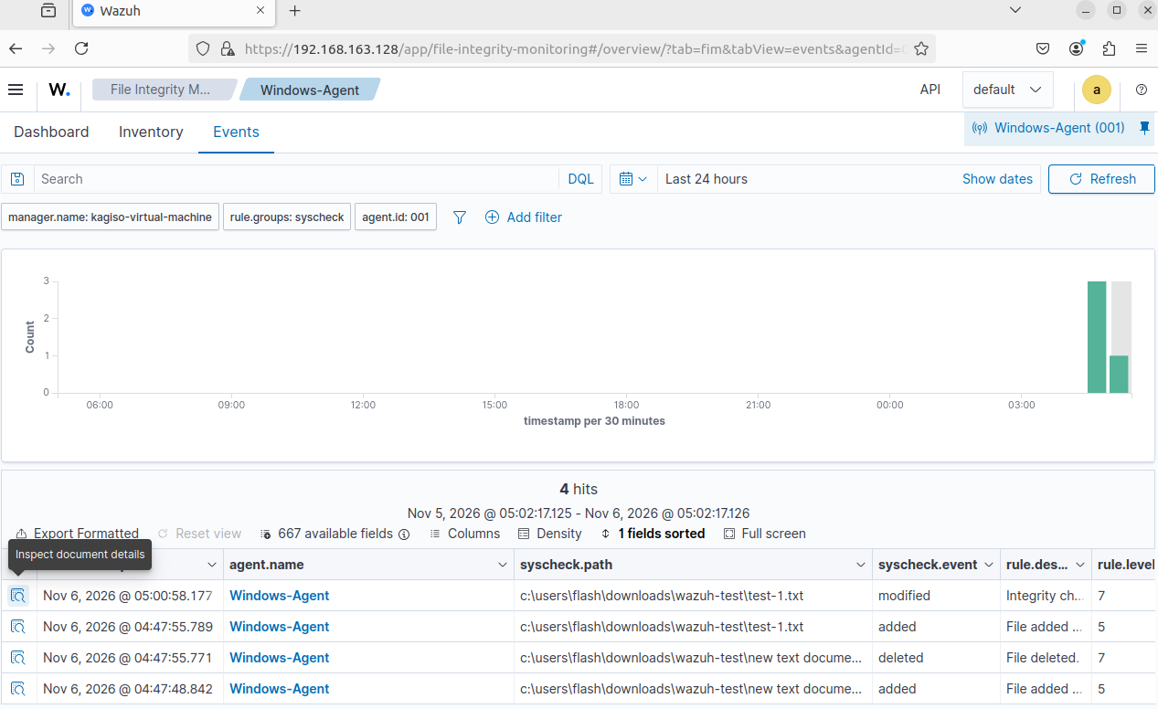
Figure 9. Events recorded for the Windows endpoint.

10. Outcome
The lab documents a Wazuh installation on Ubuntu, access to the Wazuh dashboard, Windows agent registration and confirmation that the endpoint was active. The captured Events view also demonstrates endpoint event visibility.

